**Summary – National Seminar**

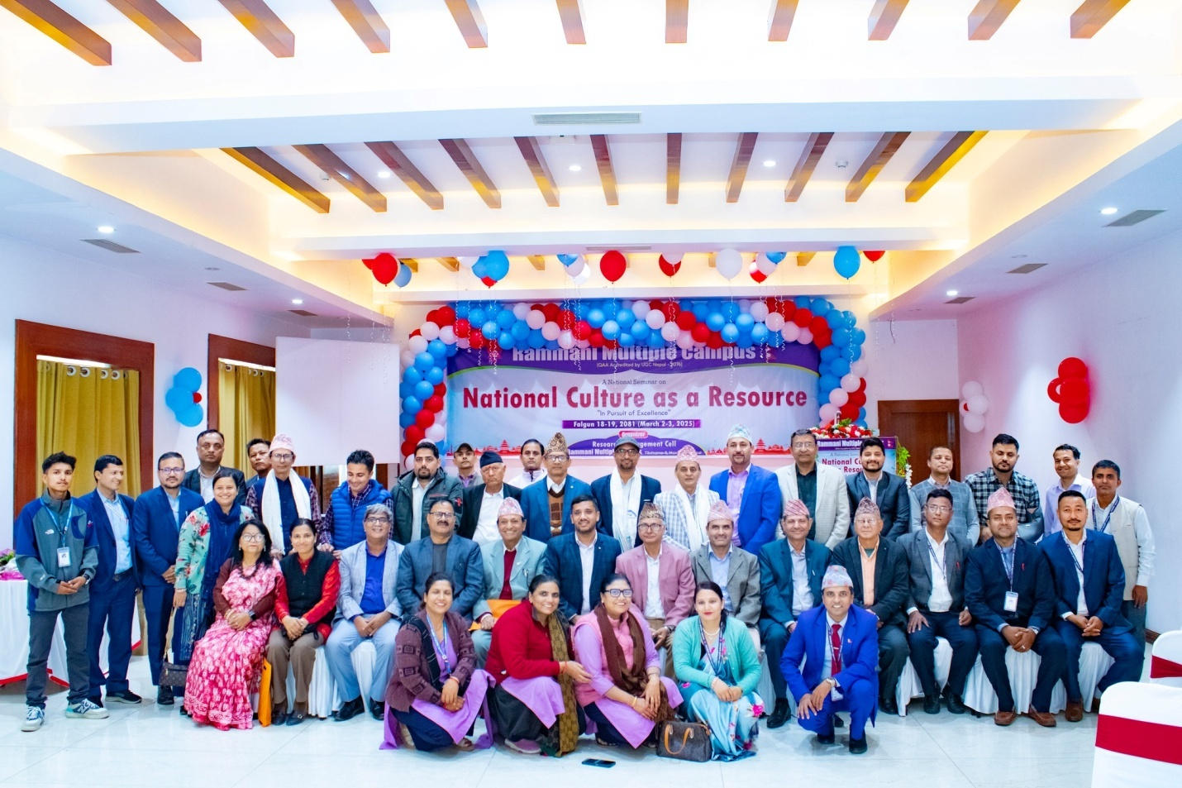

Research Management Cell at Rammani Multiple Campus organized a 2-Day National Seminar titled “National Culture as a Resource” on March 2-3, 2025 (Falgun 18-19, 2081). The 2-Day national seminar included key note sessions on the first day and technical sessions on the second day.

**1st-Day – Inauguration and Key Note Presentations**

At the inauguration session, Chairman of Management Committee, Mr. Dhruba Kumar Dhital, presided as the chair and Member of Parliament and former mayor of Tilottama Municipality, Mr. Basu Dev Ghimire was the Chief Guest in attendance. Dr. Ashok Bhandary, Coordinator of Research Management Cell welcomed those in attendance and highlighted the importance of the seminar. Following the inauguration ceremony, 3 keynote presentations were delivered.

The key note speakers (in order of presentations) were as follows:

1. Dr. Jagman Gurung, Former Vice-Chancellor of Nepal Academy

2. Dr. Krishna Chandra Sharma, Professor (Emeritus) of English at T.U. Central Department, Kirtipur

3. Dr. Tikaram Gautam, Associate Professor of Sociology at T.U. Central Department, Kirtipur

The first key note address, Dr. Jagman Gurung’s key note presentation was on the unique cultural and geographical importance of Nepal from the context of Hindu culture and religion. Dr. Gurung pointed out that *Himawat Khanda* (the Himalayas of Nepal) is in fact the abode of god Shiva and goddess Parbati and as such Nepal in general has a uniquely superb position when viewed from a socio-religious perspective.

The second key note address, Dr. Krishna Chandra Sharma’s key note presentation was on deciphering the cultural norms and traditions as explained in *Vedas* and other Hindu scriptures. Dr. Gautam highlighted that controversial practices such as *Sati Pratha* (or immolation of the living widow on deceased husband’s funeral pyre) or *Bali Pratha* (animal sacrifice at a temple) were not prescribed in Hindu scriptures, however such practices were introduced into the culture later due to situations external to the Hindu religion.

The third key note address, Dr. Tikaram Gautam’s key note presentation was on “natural, cultural, and ecological diversity for Nepal’s prosperity.” Dr. Gautam spoke on the possibility understanding socio-economic Nepal’s prosperity by exploring the natural link between nature, culture, and ecology.

Following the Key note session, Mr. Dhruba Kumar Dhital, chairman of campus management committee delivered the closing remarks for the key note sessions. Mr. Muktinath Gaihre, associate professor of English was the program anchor.

Altogether, there were 102 participants in attendance during the program. This included faculty participants from nearby universities and campuses.

**2nd Day – Technical Session**

The 2nd day of the national seminar was composed of 3 technical sessions. The 3 technical sessions were divided based on the separate streams/themes of papers. Each technical session had an assigned session chair that provided feedback on the papers presented during the session. Altogether there were 8 research paper presentations during the technical sessions.

**Technical Session I – Economics Stream**

Session chair - Dr. Babu Ram Gewali, Professor (Emeritus) of Economics, T.U.

Papers presented in Technical Session I

|  |  |
| --- | --- |
| **Presenter(s)** | **Title of Presentation** |
| Krishna Kumar Regmi  Rammani Multiple Campus | Bridging the Gap: Kautilya’s Arthashastra and Modern Economics |
| Sher Bahadur Shahi  Tribhuvan University | Production Cost of Feature Film in Nepal |

**Technical Session II – Literature, Arts Stream**

Session chair - Dr. Kapil Dev Lamichhane, Professor (Emeritus) of Nepali, T.U.

Papers presented in Technical Session II:

|  |  |
| --- | --- |
| **Presenter(s)** | **Title of Presentation** |
| Raju Bhusal  Butwal Multiple Campus | ejfgL leIf'sf] …dfw'/L gfgLÚ syfdf ;f+:s[lts k|e'Tj;DaGwL ljifos sfo{kq |
| Manjeel Subedi & Kamal Thapa  Lumbini Bouddha University | ;fF:s[lts PsLs/0fsf ;Gbe{df dfgj >f]tsf] lbuf] pkof]usf nflu l;ufnf]jfb ;'Qsf] pkfb]otf |
| Maya Ghimire  Rammani Multiple Campus | नेपाली तीज गीतमा सांस्कृतिक रूपान्तरण र लोकप्रिय संस्कृति |

**Technical Session III – Management, Sociology Stream**

Session chair - Dr. Ganesh Prasad Pathak, Professor (Emeritus) of Management, T.U.

Papers presented in Technical Session III:

|  |  |
| --- | --- |
| **Presenter(s)** | **Title of Presentation** |
| Dr. Ashok Bhandary  Rammani Multiple Campus | National culture and entrepreneurship – A review of research |
| Arpan Shrestha,  Rammani Multiple Campus | The Influence of Reference Group on Impulsive Buying Behavior with mediating role of Hedonic Shopping Behavior |
| Rajendra Thapa Magar, Pushpa KC, Rammani Multiple Campus | Bank Specific Factors and Market Price of Stock: Evidence from Nepalese Commercial Banks |

The technical sessions touched on a wide variety of topics as presented during the sessions. The topic presented included – studying how national culture affects entrepreneurship; how economics has progressed from ancient times to modern economics; studying the cost of making feature films; how women caretakers have been portrayed in Nepali literary classics; how the Nepali religious event Teej has undergone cultural transformation; how Buddha’s teachings influenced cultural transformation and unification; understanding impulsive buying behavior; and understanding the relationship between stock price and bank specific factors .

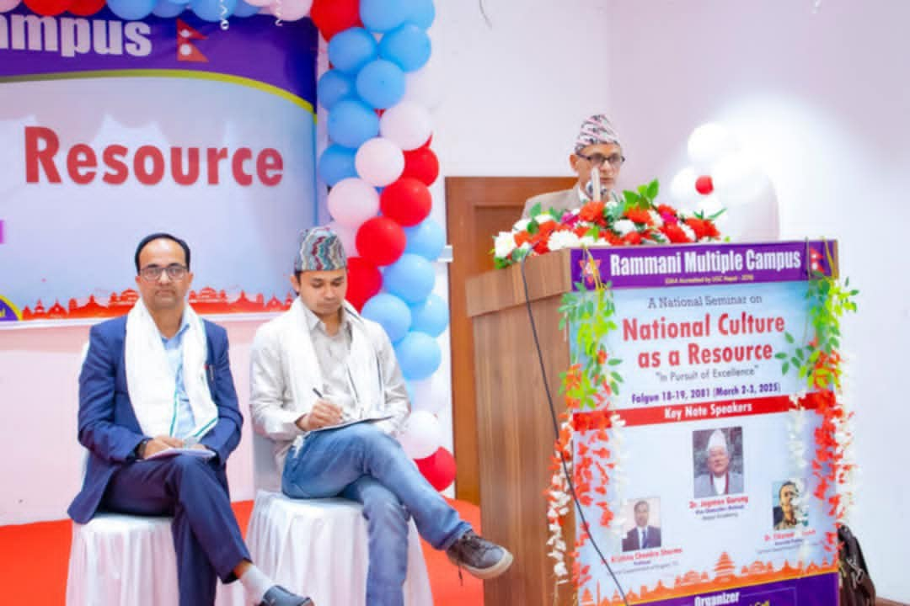

There were a total of 62 participants in attendance in the 2nd day of the seminar, i.e., during the technical sessions. Paper presenters and participants were given certificates of presentation and certificates of participation after the technical sessions were conducted. Campus Chief Tara Prasad Parajuli gave a speech thanking everyone for their participation in the national seminar program. Campus Management Committee Chairman Mr. Dhruba Kumar Dhital gave a speech with closing remarks. Mukti Nath Gaihre, associate professor of English was the program anchor for the second day as well.

**Major Outcomes of the Seminar**

1. Establishing national culture as a valuable resource that can be utilized for national prosperity.
2. Understanding that in Nepal’s context, national culture can really be a powerful tool for economic prosperity.
3. Culture is source of identity for individuals, groups, and nations
4. Laymen understanding of culture is often incomplete and this is a reason for ignoring one’s culture or adopting a new culture altogether.
5. Interaction among faculties that led to sharing of knowledge and insights.
6. Master’s students benefitted from the knowledge and wisdom shared in the seminar